Popularising science through school youtube channel

Labyrinth – gymnasium and elementary school, s.r.o.
Žerotínovo náměstí 6, Brno 602 00

Content
Project information 4
Material equipment needed to implement the project 5
Supplementary equipment and material for experiments 5
Financial complexity of the project 7
Preparation of the recording studio 8
Equipment and material 8
Basic equipment 8
Procedure and role of pupils 8
The role of pupils 8
Study preparation 9
Reflection and evaluation 13
Check list 13
Experiment No. 1 - Foil in the microwave 14
Annotation 14
Theme and RVP 14
Topic 14
RVP outputs 14
Material for the experiment 15
Procedure for conducting an experiment 15
Experiment No. 2 - Light bulb in the microwave 15
Annotation 15
Theme and RVP 16
Topic 16
RVP výstupy 16
Equipment and material 16
Basic equipment 16
Material for the experiment 17
Procedure for conducting an experiment 17
Experiment No. 3 - Fluorescent lamp in the microwave 17
Annotation 17
Theme and RVP 17
Topic 17
RVP outputs 18
Basic equipment 18
Material for the experiment 18
Procedure for conducting an experiment 19
Experiment č. 4 –Fire like you don't know it 19
Annotation 19
Theme and RVP 19
Topic 19
RVP outputs 19
Equipment and material 20
Basic equipment 20
Material for the experiment 20
Procedure for conducting an experiment 21
Links to the resulting videos 22

Project information
Project description
Pupils created a school YouTube channel and videos popularising science.
What age group is the project intended for?
For pupils from the 8th and 9th grade of elementary school.
What skills should the students know before starting the project?
The basics of video editing in your chosen software
Shooting videos on a camera/camcorder
What skills will the students learn in the project?
Pupils will try out the laws of physics in practice and at the same time create science-popularisation videos that will get other children excited about research and exploration. The videos will also be able to serve as study material in physics classes and will be available to other schools as well.
Pupils will be able to work with professional equipment – SLR camera, microphones, lighting, etc. This way, they will find out how much work and time is involved in making a short but high-quality video. Pupils edit a simple video from many recordings from different cameras.
Children plan and manage the entire project themselves. Thanks to this, they have to think about what technologies they will need, where to search and verify relevant information, and what needs to be prepared in advance and what is sufficient only during filming or post-production. They are thus able to combine skills acquired from many different sectors.

Material equipment needed to implement the project
Basic equipment
Mobile stabiliser: https://www.alza.cz/dji-osmo-mobile-3-d5655147.htm
Camera stabiliser: https://www.alza.cz/feiyutech-g6-max-d5821584.htm
Camera: https://www.megapixel.cz/sony-alpha-a6100-16-50-mm-cerny-zakladni-kit
Camera tripod: https://www.alza.cz/manfrotto-mkcompactadv-bk-d2147468.htm
Dual lapel microphone: https://www.film-technika.com/klopove-mikrofony/dualni-klopovy-mikrofon-commlite-cvm-d02-s-delkou-kabelu-2-5m/
Studio set including lights: https://www.film-technika.com/foto-pozadi/svetelny-set-pro-nepretrzite- osvetleni/?gclid=Cj0KCQiAvP6ABhCjARIsAH37rbQqJk3NCiKXHtJO0kFCC3f5HijopiTvOiDeERKgTiiW0mPT99cDMyEaApoFEALw_wcB
Recorder: https://www.megapixel.cz/zoom-h1n?gclid=Cj0KCQiA5dPuBRCrARIsAJL7oei10shOQJ35B4cvC8Bgb9WW9o7v7NWENO1hjnnKvMkYb5dbCt-45x0aAhidEALw_wcB
SDHC cards: https://www.alza.cz/pametove-karty-sdhc/18848712.htm
Studio microphone: https://www.alza.cz/rode-nt-usb-d2267927.htm
Acoustic foam: https://www.akusticka-pena.cz/zbozi-ceny/sinus-3-cm/

Supplementary equipment and material for experiments
MicroBit: https://www.hwkitchen.cz/bbc-microbit-v2-mikropocitac-pro-vyuku-programovani/
Micro:bit Smart Home Kit: https://www.hwkitchen.cz/bbc-microbit-kit-pro-chytrou-domacnost/
Arduino Super learning kit: https://www.alza.cz/hracky/arduino-super-learning-starter-kit-d5883971.htm?kampan=adwhr_hracky_pla_all_vyrobci-css_roboticke-a-digitalni_c_9062905__HRAbz02500&gclid=Cj0KCQjw8IaGBhCHARIsAGIRRYpsuVEESzeCkneXtkB_vnrwxK5vD4gfL7ZvoAys97ZB0m7wmOvV5scaAo24EALw_wcB#parametry
Micro soldering iron set with accessories:
https://www.laskarduino.cz/handskit-sada-mikropajky-s-prislusenstvim/?fbclid=IwAR316dHB52eW52o9FlKACZtxCO1yMeE-eXL3egKs4jGrs2gG3Q-liWISE588
Transformer soldering machines:
https://www.tipa.eu/cz/trafopajka-nuba-etp-4-s-75va-se-sroubkem-blistr/d-159279/ or https://www.gme.cz/transformatorova-pajecka -75w-etp4-u-75w-packaged-in-a-blister
Soldering wire 100g, with lead:
https://www.tme.eu/cz/details/lc60-1.00_0.1/pajeci-draty-olovnate/cynel/
Rosin: https://www.tipa.eu/cz/kalafuna-16g/d-86159/
Small splitters:
https://www.obchod-stroje.cz/kleste-pro-elektroniku-bocni-stipaci?gclid=CjwKCAjwt8uGBhBAEiwAayu_9dvCe4WnP9QlvMkxNij_PIeicWMqIzebfJTIJIqzrWOHCn_U3vlMlBoCc_IQAvD_BwE
Jumpsuits, length 160 cm: https://www.melichar.cz/p/kleste-kombinovane-160mm-crv
Jumpsuits, length 160 cm: https://www.melichar.cz/p/kleste-kombinovane-160mm-crv
Cleavers, length 160 cm: https://www.melichar.cz/p/kleste-stipaci-bocni-160mm-crv
Half round pliers, length 160 cm:
https://www.melichar.cz/p/extol-craft-kleste-pulkulate-prime-160mm-7018
Aquarium: https://www.akva-exo.cz/detail/akvaristik/
aquariums/a-classic-aquariums/1-small/6519/40%C3%9725%C3%9730cm/
Accessories for the micro drill:
https://www.jadal.cz/389-dilna-sada-prislusenstvi-pro-prime-brusky-hitachi-753949-transparentni-kufr/
Red laser pointer:
https://laser-shop.cz/laserova-ukazovatka/381-laserove-ukazovatko-cervene-50-mw.html
Green laser pointer:
https://laser-shop.cz/laserova-ukazovatka/11-laserove-ukazovatko-zelene-50-mw.html
Purple laser pointer:
https://laser-shop.cz/laserova-ukazovatka/385-laserove-ukazovatko-modre-fialove-50-mw.html
Thermometers: https://www.verkon.cz/teplomer-obalovy-pro-vseobecne-pouziti/
Portable microscope: https://mikroscopy.heureka.cz/levenhuk-dtx-30/
USB microscope:
https://www.exasoft.cz/levenhuk-digitalni-mikroskop-dtx-500-lcd_d145397.html

Financial complexity of the project

Basic components and material
Camera | 26 200 Kč
Camera tripod | 2 189 Kč
Camera stabiliser | 6 080 Kč
Stabilizer for mobile | 2 664 Kč
Studio set | 6 500 Kč
Studio microphone | 4 700 Kč
Recorder | 2 500 Kč
Dual lapel microphone | 3 600 Kč
SDHC cards | 1 500 Kč
Acoustic foam | 4 50 Kč
In total | 56 383 Kč

Preparation of the recording studio

Equipment and material

Basic equipment
- 3 softboxes for lighting
- desk
- keyring background with racks
- two large tripods
- two cameras
- gopro camera and small gopro tripod
- 2 lapel microphones

Procedure and role of pupils

The role of pupils
- 2 students are cameramen (each behind a tripod with a camera) - they instruct where the performers can move. In addition, they ensure that the experiment will be seen all around.
- 1-2 pupils in front of the camera, demonstrating the experiment and at the same time explaining its principle. Good articulation is important.
- 1-2 students propose a topic and an experiment to verify the phenomenon.
- 1-2 pupils create a scenario with an understandable explanation.

Here, the teacher is in the role of a professional assistant who verifies the correctness of the facts. Supervises the progress of filming, suggests possible facilitation of production.

Study preparation

Preparing the studio: Before the shooting itself, the studio had to be prepared for the shooting. This means preparing the table on which the experiments will take place. Behind it, build a structure with a canvas for subsequent Chroma key composition of the background.

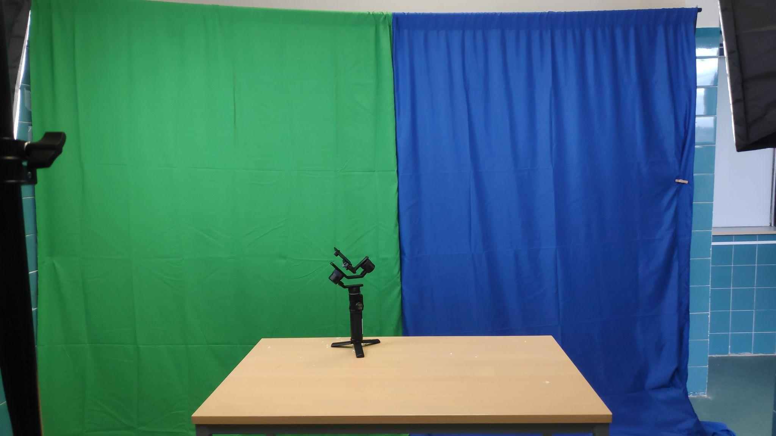
In the next step, the lighting needs to be adjusted appropriately so that the children do not have shadows under their noses, but at the same time their faces look plastic and not stiff. We used a combination of three softboxes placed at different distances, see photos.

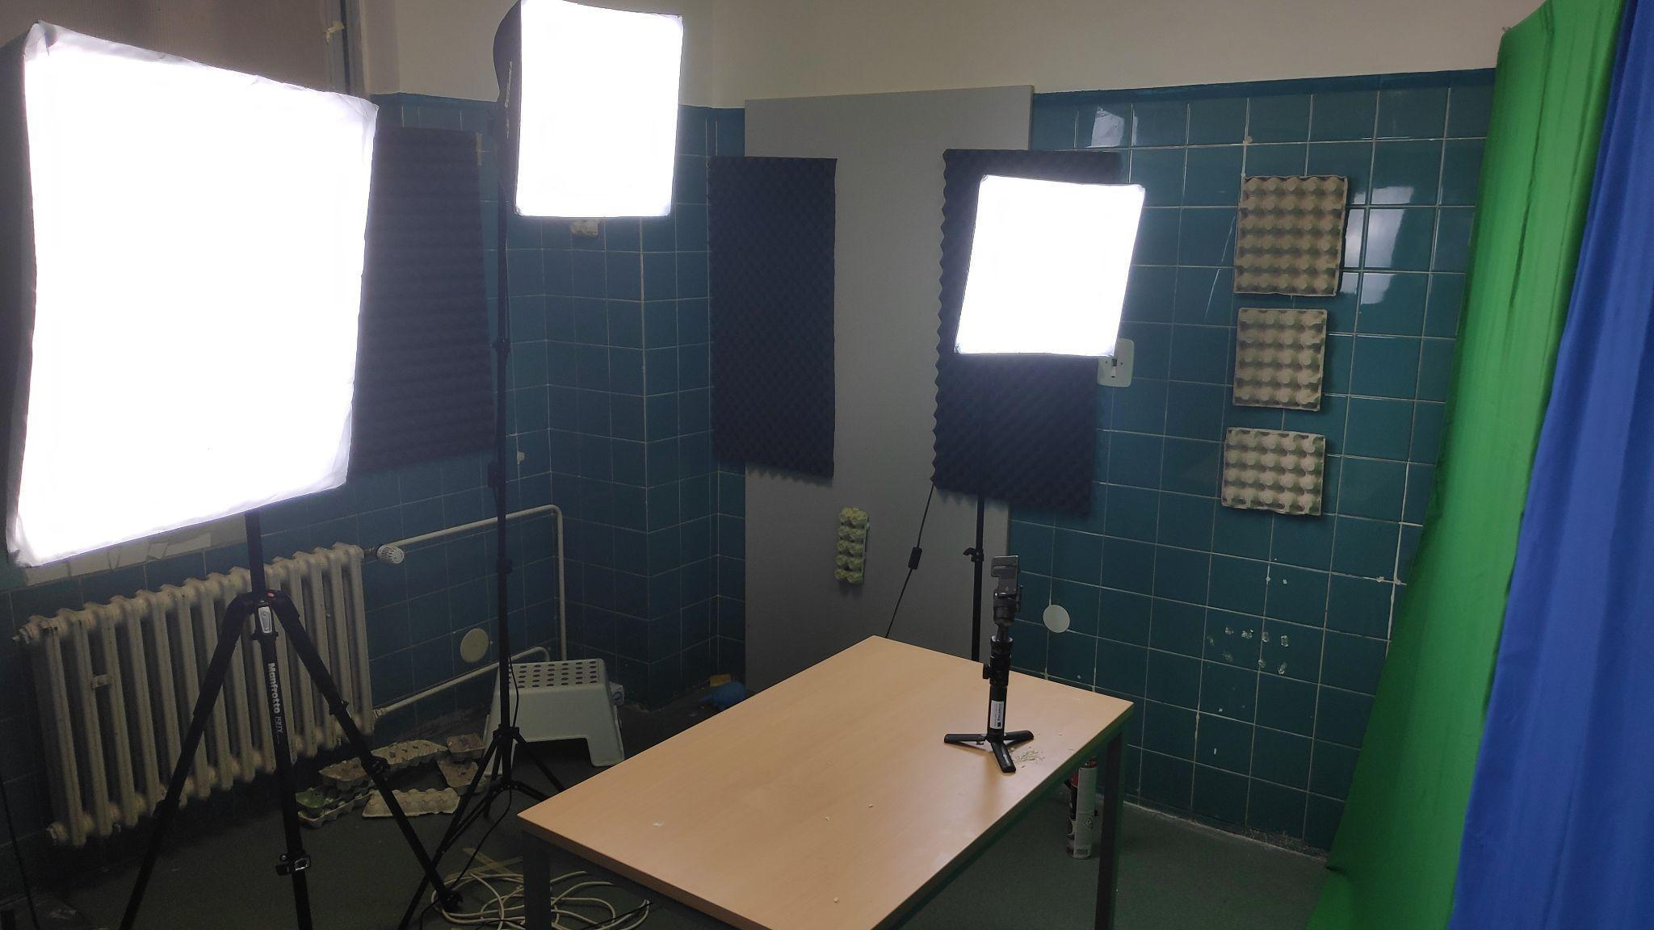
The shooting itself was preceded by a search for information about how the given physical phenomenon works. This was followed by a consultation with the teacher, when it was necessary to explain and clarify the correctness of some formulations.

Pupils created a simple scenario with the text that they will say and the sequence of individual scenes. The students used the scenario itself rather as a support, but then presented the phenomenon in their own words, which seemed much more natural.

We recommend that you prepare several experiments for one shooting. We prepared a whole series of experiments. We chose experiments on a similar topic, from which one larger integrated video was created.

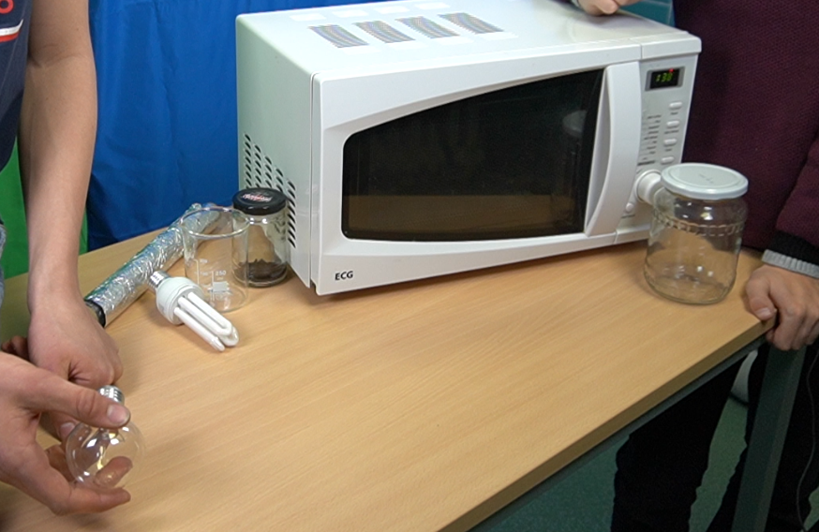

After preparing the necessary material on the table, we checked the functionality of the cameras, microphones and lighting and the connection of the microwave oven.

The filming itself followed, when we shot the scene with two basic cameras - one covered the whole scene - the performers and the table, the other covered the detail and during the filming moved and changed the detail of the shot as needed. It is advisable for one of the students to be present throughout the filming and to operate and check the camera in the event of a breakdown or the need to change or adjust the scene.
It is also necessary to check that the camera does not capture parts of the room that do not belong in the scene.

After all this the shooting itself was underway. It is always a good idea to repeat the scene several times, especially for mistakes and other oversights. Warn the students that they must not decrease their energy if we repeat the shot even for the fifth time. It is very demanding, but you always need to film as if it was the first shot.
The video should contain an introductory greeting and an introduction to the topic, followed by the experiment itself. We filmed both from a distance and a close-up with a small GoPro camera that recorded the inside of the microwave oven (through the door).

This was followed by an explanation of the experiment and the end of the entire video.

Subsequently, it was necessary to use the abilities of the student, who is familiar with the environment of video editing and chroma keying. All the recorded videos were sent to him, and with the help of his classmates, they continued to work on the project at home. He often informed us about his work in the group through the Viber application, where he asked for any help,advice and opinions.

Music has been added to the video. Here you need to think about the fact that the music is not distracting and at the same time complements the atmosphere of the video itself. It should only be instrumental music. We also familiarised the children with copyright licences so that the video could be further published without violating the copyright law. We searched for free music online.

The resulting material will serve as the content of the newly emerging scientific popularisation channel at our school.

Reflection and evaluation
Upon completion of the entire video, it is important to reflect on the process. As this is a project that is repeated and further developed, it is always necessary to summarise what went well and what could be done differently or done better. It is important to look at the resulting video and gradually reflect on the entire creation process.

Check list
How was the preparation?
Did the coordination of cameras and performers work?
Were the cameras in the right places?
Were the performers sufficiently prepared in front of the camera?
Did we have sufficient knowledge background?
Did we draw from quality sources?
Were the experiments successful? Why not? Did we test them enough before filming?
How did the students feel in the individual roles? Would they welcome a change?
What did the students feel lost about or what was difficult for them and what would they like help with next time?
How satisfied are they with the result? What could be improved?

The output of the feedback should be written down and keep in mind the required changes when making the next videos.

Experiment No. 1 - Foil in the microwave

Annotation
Have you ever been afraid to put a metal object in the microwave? What happens after you put the foil in and turn on the oven? How to film these physical phenomena? How and where to search for relevant information on the internet? How to present newly acquired knowledge? Students will go through the process of planning a science popularisation video. They will think about what technologies and materials they will need and where this material could be obtained. They will also learn to work with information and verify the appropriateness of sources. Last but not least, they work with digital technologies for recording images and sound and with software for cutting and editing video. They will also learn to formulate sentences intelligibly and present the newly acquired knowledge in an understandable and entertaining way.

Theme and RVP

Topic
To present and demonstrate a physical phenomenon in which sparks start to appear on the surface of aluminum foil if we put it in a microwave oven, which we then turn on. Pupils will explain why it is necessary to hide the foil in a protective glass and explain what damage could happen to the microwave oven. They will present everything comprehensible in the resulting scientific popularization video.

RVP outputs
F-9-1-02 will give specific examples of phenomena proving that the particles of matter constantly move and affect each other
F-9-6-03 distinguishes between a conductor, an insulator, and a semiconductor based on an analysis of their properties
VV-9-1-03 captures phenomena and processes in changes and relationships; to create, it uses some methods applied in contemporary visual arts and digital media – computer graphics, photography, video, animation
ČSP-9-7-01 controls the basic functions of digital technology; diagnoses and eliminates basic problems in the operation of digital technology ČSP-9-7-02 connects individual digital devices to each other
ČSP-9-7-04 treats digital technology and protects it from damage
I-9-1-01 obtains information from the data, interprets the data, detects errors in other people's interpretations of the data
I-9-4-02 stores and manages its data in a suitable format with regard to their further processing or transmission

The activity will connect various RVP outputs and train the digital competences themselves when searching for information and creating and processing digital content.

Material for the experiment
- microwave
- canning jar – closable
- tin foil

Procedure for conducting an experiment

- We will prepare a sealable canning jar, piece of aluminium foil, which we will gently crumple, and we will connect the microwave oven to electricity.
- Place the crumpled foil in the jar and close it carefully.
- Place the glass with foil in the microwave oven and close the door.
- To get a better view of what is happening inside the microwave oven, we place the camera just in front of the door and turn it on.
- We turn on the oven and watch the foil light up and throw sparks.
- After the experiment, the jar must be removed with the help of a cloth or gloves to avoid burns from the hot glass.

Experiment No. 2 - Light bulb in the microwave

Annotation
How is it possible for an ordinary light bulb to light up if we put it in the microwave and turn it on? Where does the electrical energy come from?

Theme and RVP

Topic
To present and demonstrate the physical phenomenon in which a light bulb lights up if we put it in a microwave oven, which we then turn on. Pupils will explain why the light bulb needs to be in a protective glass and explain what damage will occur to the light bulb. They will present everything comprehensible in the resulting scientific popularisation video.

RVP výstupy
F-9-1-02 will give specific examples of phenomena proving that the particles of matter constantly move and affect each other
F-9-6-03 distinguishes between a conductor, an insulator, and a semiconductor based on an analysis of their properties
VV-9-1-03 captures phenomena and processes in changes and relationships; to create, it uses some methods applied in contemporary visual arts and digital media – computer graphics, photography, video, animation
ČSP-9-7-01 controls the basic functions of digital technology; diagnoses and eliminates basic problems in the operation of digital technology ČSP-9-7-02 connects individual digital devices to each other
ČSP-9-7-04 treats digital technology and protects it from damage
I-9-1-01 obtains information from the data, interprets it data, reveals errors in foreign interpretations of data
I-9-4-02 stores and manages its data in a suitable format with regard to their further processing or transmission

The activity will connect various RVP outputs and train the digital competences themselves when searching for information and creating and processing digital content.

Equipment and material

Basic equipment
- 3 softboxes for lighting
- desk
- keyring background with racks
- two large tripods
- two cameras
- gopro camera and small gopro tripod
- 2 lapel microphones

Material for the experiment
- microwave
- canning jar – closable
- bulb

Procedure for conducting an experiment
- We will prepare a light bulb, a microwave oven connected to electricity and a sealable canning jar.
- Place the light bulb in the jar and close it carefully.
- Place the jar with the light bulb in the microwave oven and close the door.
- To get a better view of what is happening inside the microwave oven, we place the camera just in front of the door and turn it on.
- We turn on the oven and watch the bulb light up.
- After the experiment, the jar must be removed with the help of a cloth or gloves to avoid burns from the hot glass.

Experiment No. 3 - Fluorescent lamp in the microwave

Annotation
How is it possible that a fluorescent lamp lights up if we put it in the microwave and turn it on? Where does the electrical energy come from?

Theme and RVP

Topic
To present and demonstrate the physical phenomenon in which a light bulb lights up if we put it in a microwave oven, which we then turn on. Pupils will explain why a fluorescent lamp must be hidden in a protective glass with water and explain how a fluorescent lamp differs from a light bulb and why it will not be damaged like a light bulb. They will present everything comprehensible in the resulting scientific popularisation video.

RVP outputs
F-9-1-02 will give specific examples of phenomena proving that the particles of matter constantly move and affect each other
F-9-6-03 distinguishes between a conductor, an insulator, and a semiconductor based on an analysis of their properties
VV-9-1-03 captures phenomena and processes in changes and relationships; to create, it uses some methods applied in contemporary visual arts and digital media – computer graphics, photography, video, animation
ČSP-9-7-01 controls the basic functions of digital technology; diagnoses and eliminates basic problems in the operation of digital technology ČSP-9-7-02 connects individual digital devices to each other
ČSP-9-7-04 treats digital technology and protects it from damage
I-9-1-01 obtains information from the data, interprets the data, detects errors in other people's interpretations of the data
I-9-4-02 stores and manages its data in a suitable format with regard to their further processing or transmission

The activity will connect various RVP outputs and train the digital competences themselves when searching for information and creating and processing digital content.

Basic equipment
- 3 softboxes for lighting
- desk
- keyring background with racks
- two large tripods
- two cameras
- gopro camera and small gopro tripod
- 2 lapel microphones

Material for the experiment
- microwave
- canning jar – closable
- water
- fluorescent lamp

Procedure for conducting an experiment
- We will prepare a fluorescent lamp, a microwave oven connected to electricity and a closable canning jar, into which we will pour about ⅕ of the volume of water.
- Insert the fluorescent tube into the jar with a thread dipped in water and close it carefully.
- Place the jar with the light bulb in the microwave oven and close the door.
- To get a better view of what is happening inside the microwave oven, we place the camera just in front of the door and turn it on.
- We turn on the oven and watch the bulb light up.
- After the experiment, the jar must be removed with the help of a cloth or gloves to avoid burns from the hot glass.

Experiment no. 4 –Fire like you don't know it

Annotation
What color is the flame? Why are fireworks colorful? How to film these physico-chemical phenomena?

Theme and RVP

Topic
Present and demonstrate the physico-chemical phenomenon in which the colour of the flame changes after the addition of various chemical elements. Pupils will explain why the flame changes color after adding sodium, copper or perhaps cesium. It will explain where we encounter this phenomenon in everyday life and how this method is used, for example, in the analysis of solutions. They will present everything comprehensible in the resulting scientific popularization video.

RVP outputs
F-9-1-02 will give specific examples of phenomena proving that the particles of matter constantly move and affect each other
VV-9-1-03 captures phenomena and processes in changes and relationships; to create, it uses some methods applied in contemporary visual arts and digital media – computer graphics, photography, video, animation
ČSP-9-7-01 controls the basic functions of digital technology; diagnoses and eliminates basic problems in the operation of digital technology ČSP-9-7-02 connects individual digital devices to each other
ČSP-9-7-04 treats digital technology and protects it from damage
I-9-1-01 obtains information from the data, interprets the data, detects errors in other people's interpretations of the data
I-9-4-02 stores and manages its data in a suitable format with regard to their further processing or transmission
CH-9-3-01 uses the terms atom and molecule, element and compound in the correct contexts
CH-9-3-02 orients itself in the periodic table of chemical elements, recognizes selected metals
and nonmetals and deduces their possible properties

The activity will connect various RVP outputs and train the digital competences themselves when searching for information and creating and processing digital content.

Equipment and material

Basic equipment
- 3 softboxes for lighting
- desk
- keyring background with racks
- two large tripods
- two cameras
- gopro camera and small gopro tripod
- 2 lapel microphones

Material for the experiment
- frying pan (or other heat-resistant container)
- ethanol (technical alcohol)
- Wash bottle - number according to the amount of tested solutions
- solutions containing various metals (example: table salt solution - sodium; blue rock - copper; potassium nitrate - potassium,...)
- lighter

Procedure for conducting an experiment
- First, you need to prepare the solutions
- all solutions were prepared in distilled water, you can use:
- table salt (NaCl) - golden flame
- blue rock (CuSO4) - green flame
- potassium nitrate (KNO3) - violet flame
- lithium nitrate (LiNO3) - red flame and other metal compounds.
- Pour the solutions into the sprayer (they must be clean)
- We will prepare a heat-resistant bowl on the table (we used a friction bowl) into which we will pour ethanol (technical alcohol)
- Light the ethanol and gently inject the solutions into the flame gradually. The flame becomes colored.

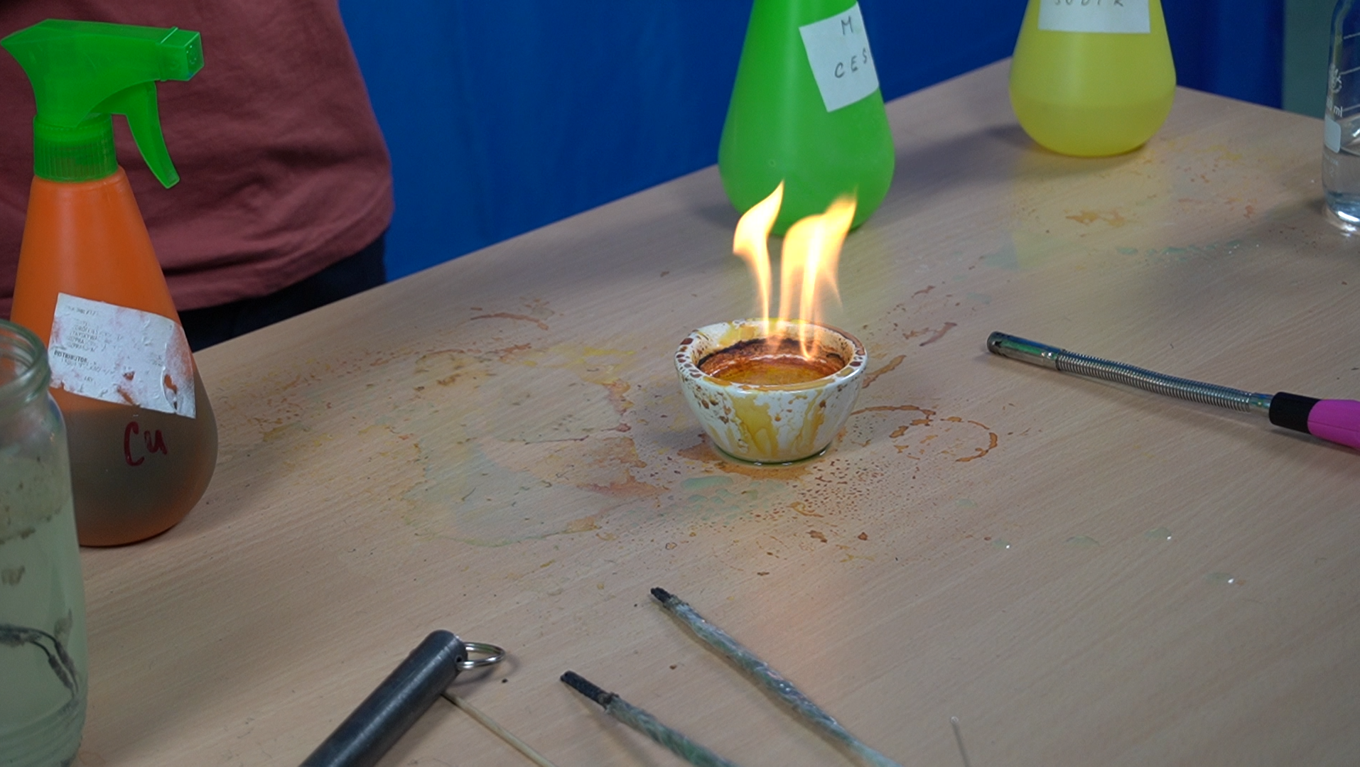

Links to the resulting videos

ScienceLAB – school YouTube channel - https://www.youtube.com/channel/UCiFM0GhcN3hZmucBND0-edg
Fire how you don't know it - https://www.youtube.com/channel/UCiFM0GhcN3hZmucBND0-edg
How your plasma reactor works - https://www.youtube.com/watch?v=7ieKPXbHy0E&ab_channel=ScienceLAB

